Shem Katz  Dive Guide · Underwater Photographer · SSI Open Water Instructor  Currently in Puerto Escondido, Oaxaca, Mexico · Mexican residency visa with permission to work  shemkatz@hotmail.com · +52 987 100 5337 · Photography: @shemkatz · shemkatz.com (WIP) | 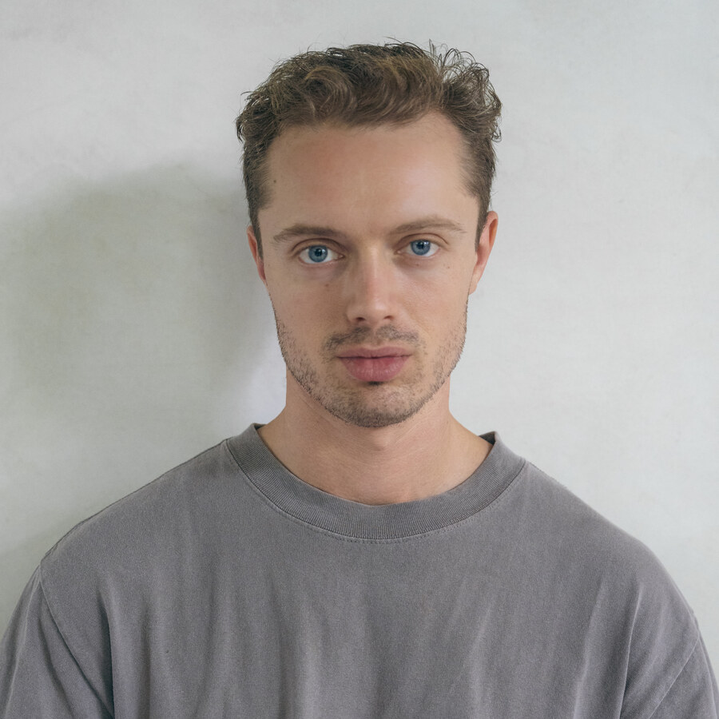

300+  LOGGED DIVES | SSI  OPEN WATER INSTRUCTOR | 3  COUNTRIES WORKED | EN / ES / NL  LANGUAGES

PROFILE
Freelance dive guide and underwater photographer, working seasons in Mexico and Curaçao. After five years as a data scientist, I took the leap and pursued my two passions: the ocean and photography. I have since permanently moved to Mexico having fallen for the country. I am looking for new opportunities, and I cannot think of anything more exciting than diving Socorro and the Sea of Cortez —the month-on / month-off rotation suits me well. My background across hospitality, banking, diving and photography gives me a range that I think would serve Nautilus well, and it means I connect easily with every kind of guest.
DIVING EXPERIENCE
Dive Guide & Photographer | Cozumel, Mexico | Oct 2024 – present (seasonal)
- Guided drift and deep dives on the Cozumel reefs.
- Daily diving operations, predominantly from the boat.
- Private underwater photo shoots for guests.
Underwater Content Creation | Fiji | Oct 2025
- Three-week underwater content assignment.
Dive Guide, First Mate & Photographer | Curaçao | Mar – Sep 2025
- First mate to the captain: boat set-up, docking, cleaning and turnaround between trips.
- Guided shore and boat dives, and looked after guests on board throughout the day.
- Shot stills through the season, for guests and for the centre.
SKILLS
SSI Open Water Instructor | Comfortable guiding in current, at depth and at night.
Underwater photographer | Specialising in wide-angle, working mostly on private commissions.
Hospitality | Several years in bars and restaurants, latterly as manager.
Languages | English (native) · Spanish (conversational, used daily) · Dutch (conversational).
Data science | Five years modelling credit risk and pensions at ABN AMRO and ELAVV; taught Python to colleagues and clients.
Education | MSc Actuarial Science and Mathematical Finance, University of Amsterdam. BSc Financial Mathematics, First Class.
UNDERWATER PHOTOGRAPHY
I shoot underwater and on land and publish the work at shemkatz.com (work in progress) and on Instagram @shemkatz — reef life, night dives, wrecks and over-under splits. As an addition, I would love to collaborate with Nautilus whether that be for marketing purposes or for guests where possible.
Available immediately · Happy to relocate to Baja, or to travel out whenever a trip is due

